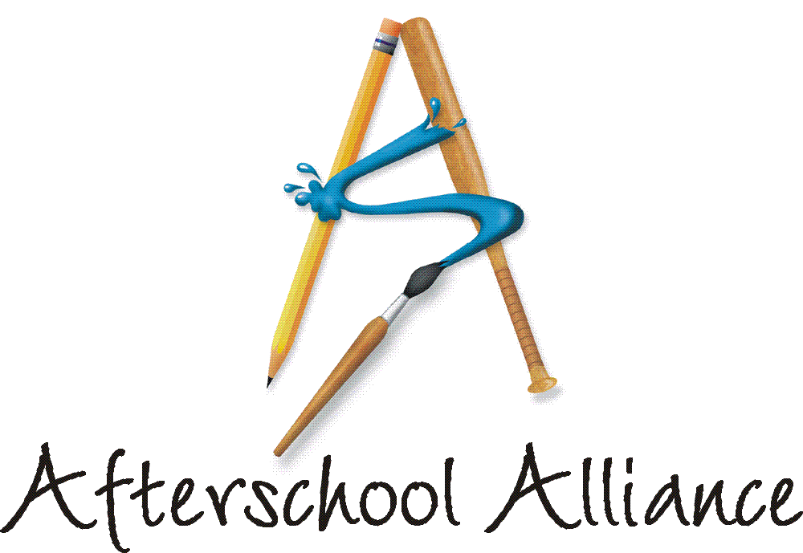

News Release Contact: Matt Freeman or Gretchen Wright
October 9, 2002 202/371-1999

New Poll: Voters See Afterschool Programs
As Key to Keeping Kids Safe, Helping Them Learn

Voters Disagree with Bush Plan for No Increase in Federal Afterschool Funds

Washington, DC – Even with new concerns about the economy, terrorism and war, American voters overwhelmingly support the afterschool programs that keep kids safe and healthy, help working families and improve academic achievement. They see afterschool programs as key to keeping children safe during the sometimes-perilous afternoon hours, and want government to provide more adequate funds for these programs. Those are among the findings of a telephone survey of registered voters age 18 and older conducted for the Afterschool Alliance by Lake Snell Perry & Associates and The Tarrance Group from August 13 to 21.

Nine in ten voters agree that there should be some type of organized activity or place for children to go after school every day that provides opportunities for them to learn, the survey found. By a two-to-one margin (59 to 28 percent), voters disagree with President Bush’s decision, as reflected in his 2003 budget, to “not increase funding for afterschool programs beyond their current level.” The “No Child Left Behind Act,” passed by Congress last December and signed by President Bush this January, authorized $1.5 billion for the federal 21st Century Community Learning Centers program in Fiscal Year 2003 – but President Bush’s budget called for just $1 billion. Nearly two-thirds of voters (63 percent) are concerned that existing afterschool programs may have to reduce services or close their doors because no new funds are available.

“The poll results speak volumes about voter support for making afterschool universally available,” said Afterschool Alliance Executive Director Judy Y. Samelson. “Even at a time when the country faces so many new challenges, voters overwhelmingly support afterschool programs and want lawmakers to devote more resources to these programs.”

Overall, 72 percent of voters agree that “afterschool programs are an absolute necessity for your community.” Support holds across all demographic groups – by race, age, partisan affiliation, geographic region, gender, level of education, marital status, urban/suburban/rural, religion, type of employment and salary. Seventy-four percent of respondents who describe themselves as “almost certain” to vote this November agree with the statement. Four of five parents (82 percent) who say they are home in the afternoon when their children return from school describe afterschool programs as an absolute necessity for their communities.

more
Add One

Parents whose children are currently enrolled in afterschool programs affirm the view that afterschool programs keep their children safe. Fully 95 percent agree that their own children are “safer and less likely to be involved in juvenile crime than children who aren’t in afterschool programs.” Ninety-two percent of these parents say their children do “better in reading, writing and math since attending an afterschool program” and 87 percent say their children are “more likely to avoid drugs and alcohol since attending an afterschool program.”

Asked to choose the most important benefit of afterschool from among a list, 42 percent of voters said afterschool programs “keep kids safe and out of trouble.” Other benefits respondents cited: help working families by providing afterschool care, and provide academic enrichment.

Other findings from the new poll:

- Asked to describe the effectiveness of four types of crime-prevention programs, voters give highest ratings to afterschool programs (78 percent very or somewhat effective) – even higher than mentoring programs (77 percent), classroom violence-prevention programs (69 percent), and gang outreach and prevention programs (69 percent). Parents of children under age 18 are even stronger in their support: 85 percent say afterschool programs are very or somewhat effective at keeping children safe.
- Asked where they “most want to see afterschool programs take place,” 58 percent choose public schools, 19 percent cite community organizations, eight percent choose “other public facilities like parks and recreation departments,” and three percent choose churches and temples.
- Just five percent of respondents support giving an advantage to faith-based organizations in federal grants to support afterschool programs – a policy that U.S. Secretary of Education Rod Paige announced this summer. Thirty-five percent say they think preference should go to schools, eight percent cite community-based organizations, and a plurality (48 percent) say all grant applicants should be treated equally.
- Asked to assess the level of commitment of a number of afterschool stakeholders, voters gave the lowest mark to federal officials. Nine in ten (92 percent) said parents of school-age children were very or somewhat committed to “quality afterschool programs.” School boards ranked next with 80 percent judging them very or somewhat committed. Respondents’ communities at large followed with 79 percent, then the respondents themselves with 63 percent, local businesses (57 percent), their mayor (54 percent), their state representative (51 percent), and their governor (also 51 percent). Federal officials lag behind in voters’ estimation of commitment to afterschool. Senators were judged very or somewhat committed by 45 percent of voters, the respondents’ Member of Congress and the President of the United States were each judged very or somewhat committed to afterschool by just 40 percent of voters.
more
Add Two

“Voters recognize that afterschool programs provide significant benefits to children, families and communities,” Samelson added. “They do not want afterschool programs to be forced to reduce hours or services, or close their doors, due to inadequate funding. Americans recognize that afterschool programs are a wise investment in our future.”

Findings were based on a telephone survey of 800 adults, aged 18 and older, who are registered voters. The margin of error in the poll is +/- 3.5 percent. It was funded by JCPenney Afterschool and the C.S. Mott Foundation.

The poll was released on the eve of Lights On Afterschool!, a nationwide event organized by the Afterschool Alliance that will feature more than 5,000 rallies for afterschool across the nation. Actor and children’s advocate Arnold Schwarzenegger is National Chair of Lights On Afterschool! and JCPenney Afterschool is the National Presenting Sponsor. Rallies for afterschool around the country will feature actress Rhea Perlman, newly crowned Miss America Erika Harold, as well as governors, mayors, legislators, educators, students, parents and others. More than 100 organizations that represent the interests of children are participating in this year’s events. Partners include: America’s Promise; American Federation of Teachers; Council of Chief School Officers; National Association of Counties; National Partnership for Women & Families; National Recreation and Park Association; Reading is Fundamental; and leading afterschool providers including Boys & Girls Clubs of America, 4-H, Junior Achievement and YMCA of the USA.

The Afterschool Alliance is a nonprofit public awareness and advocacy organization supported by a group of public, private, and nonprofit entities dedicated to ensuring that all children and youth have access to afterschool programs by 2010. The Alliance is proud to count among its founding partners the C.S. Mott Foundation, U.S. Department of Education, JCPenney Afterschool, Open Society Institute/The After-School Corporation, the Entertainment Industry Foundation and the Creative Artists Agency Foundation.

# # # #

NOTE: The survey is available at www.afterschoolalliance.org. For more information, contact Matt Freeman or Gretchen Wright at 202/371-1999.

