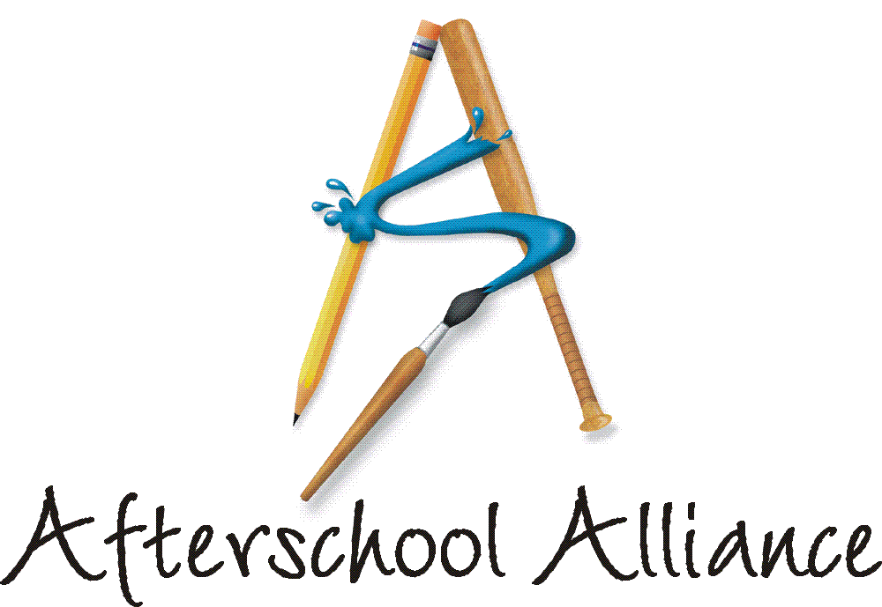
NEWS RELEASE CONTACT: Lisa Lederer
October 9, 2003 202/371-1999

Arnold Schwarzenegger, Rhea Perlman, Governors, Mayors,
State Legislators Join Parents, Childen and Educators
For Nation’s Largest Afterschool Rally Ever

“Afterschool is key to kids’ success” was the rallying cry from Augusta to Anchorage as supporters of afterschool from all walks of life came together for the fourth annual Lights On Afterschool! today. Actor, children’s activist and California Governor-elect Arnold Schwarzenegger kicked-off the events with a rally Sunday in Los Angeles. Schwarzenegger is serving as the National Chair of Lights On Afterschool! for the third consecutive year. Actress and longtime afterschool supporter Rhea Perlman also served as a spokesperson for Lights On Afterschool! this year. Organized by the Afterschool Alliance, Lights On Afterschool! included more than 5,000 rallies across the country. The JCPenney Afterschool Fund is National Presenting Sponsor.

From the steps of City Hall in New York City to the Grand Forks AirForce Base in North Dakota to a John’s Incredible Pizza Amusement Park in Modesto, California, lawmakers, community and business leaders, creative artists and religious leaders voiced their support for the afterschool programs that keep kids safe, help working families and improve academic achievement.

“It is awesome and inspiring to see so many people, all over the country, joining forces to tell lawmakers to put kids first and provide afterschool programs for all,” said Afterschool Alliance Executive Director Judy Y. Samelson, who attended Lights On Afterschool! rallies in California, the District of Columbia, New Hampshire and Ohio. “With support like this, we are sure to meet our goal of ‘afterschool for all’ by the year 2010.”

“Lights On Afterschool! is a celebration of afterschool and a reminder about how much afterschool programs matter to families and communities,” said Ed Solczak, Vice President of the JCPenney Afterschool Fund. “Afterschool programs help children flourish while keeping them safe after the school day ends. JCPenney and the JCPenney Afterschool Fund are deeply committed to afterschool programs.” Hundreds of JCPenney store managers joined Lights On Afterschool! events in their communities today.

This year, Lights On Afterschool! included events in all 50 states as well as in Guam, Japan and South Korea.

more
Add One

The day also included a special webcast organized by Kidz Online entitled, “Who wants to be a Multimedianaire?” Virginia and DC-area school children produced the webcast, which featured an afterschool quiz with prizes for the winners. Afterschool children across the country logged on to www.kidzonline.org/nnkol to answer questions and win prizes at 6 PM Eastern Time today.

A diverse group of more than 120 education, civic, arts, parents, government and other groups are supporting Lights On Afterschool! this year. Among them are Americans for the Arts, General Federation of Women's Clubs, National Council of La Raza and National Inventors Hall of Fame.

Nationwide, as many as 15 million latchkey children have no adult supervision during non-school hours. These youth are more likely to become involved in risky behavior, and are missing important opportunities to learn and grow. Afterschool programs offer young people safe, enriching, fun and engaging places to go once the school day is over. Research shows that afterschool programs are a good investment. They improve academic achievement, keep kids safe, help working families, and teach children social skills and conflict resolution. Afterschool programs also lead to increased school attendance and lower dropout rates.

A full list of the more than 5,000 Lights On Afterschool! events for 2003 is available at www.afterschoolalliance.org/loa_2003/find.cfm.

The Afterschool Alliance is a nonprofit public awareness and advocacy organization supported by a group of public, private, and nonprofit entities dedicated to ensuring that all children and youth have access to afterschool programs by 2010. Arnold Schwarzenegger is Honorary Chair of the Afterschool Alliance. Information is available at www.afterschoolalliance.org.

The JCPenney Afterschool Fund is a nonprofit, 501(c)(3) organization contributing financial support to five of America’s leading after school advocates – the YMCA of the USA, Boys & Girls Clubs of America, 4-H, Junior Achievement and the Afterschool Alliance. Support from the JCPenney Afterschool Fund helps provide safe, fun and educational after school programs and raise awareness of the need for more such programs across the country.

# # # #

