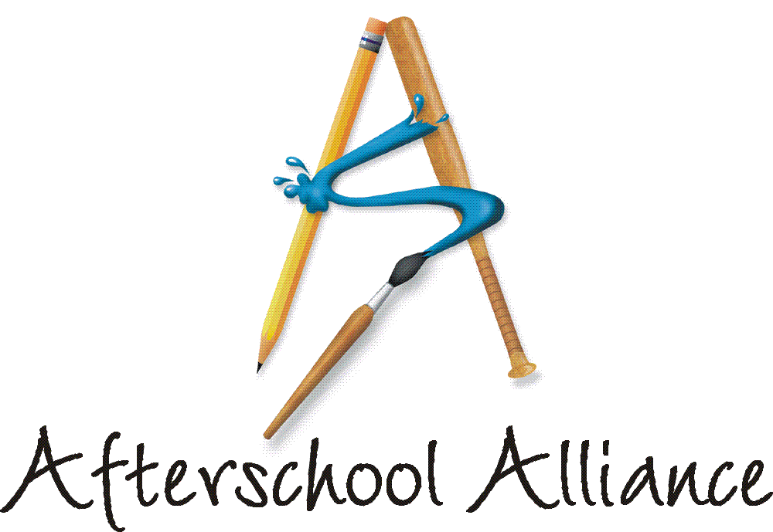
NEWS RELEASE CONTACT: Gretchen Wright
October 8, 2003 202/371-1999

National Rally for Afterschool to Go Online

Kidz Online Teams Up with Afterschool Alliance for Lights On Afterschool! Webcast

The Afterschool Alliance and the JCPenney Afterschool Fund are teaming up with a new partner to take the message that afterschool is key to kids’ success to the world wide web. The new Lights On Afterschool! partner is Kidz Online, a nonprofit organization that provides innovative peer-to-peer technology training on the Internet. Tomorrow – on Thursday, October 9, at 6 PM Eastern Time – Kidz Online will conduct a Lights On Afterschool! webcast with children from D.C. and Virginia afterschool programs. Lights On Afterschool! is organized by the Afterschool Alliance. The JCPenney Afterschool Fund is National Presenting Sponsor.

The Lights On Afterschool! webcast will feature a discussion of afterschool programs with Jennifer Rinehart, Afterschool Alliance Associate Director and Michael Petrilli, Associate Deputy Under Secretary at the U.S. Department of Education. It also will feature an afterschool quiz for students at the studio and students who view the event online, with prizes for winners. The hour-long webcast will be accessible at the Kidz Online website, www.kidzonline.org/nnkol

A complete list of Lights On Afterschool! events around the country is available at www.afterschoolalliance.org.

The Afterschool Alliance is a nonprofit public awareness and advocacy organization supported by a group of public, private, and nonprofit entities dedicated to ensuring that all children and youth have access to afterschool programs by 2010.

The JCPenney Afterschool Fund is a nonprofit, 501(c)(3) organization contributing financial support to five of America’s leading after school advocates – the YMCA of the USA, Boys & Girls Clubs of America, 4-H, Junior Achievement and the Afterschool Alliance. Support from the JCPenney Afterschool Fund helps provide safe, fun and educational after school programs and raise awareness of the need for more such programs across the country.

Nortel Networks Kidz Online (NNKOL) is a nonprofit educational organization dedicated to preparing K-12 students and teachers to live and work in the information age through innovative peer-to-peer technology training distributed using advanced digital technologies. The NNKOL Digital Studio has been constructed at Virginia's Center for Innovative Technology (CIT) in Herndon Virginia, to help students and teachers develop skills to increase their knowledge of the rapidly changing world of technology. Nortel Networks, the signature sponsor, is providing the optical network hardware for a multi-gigabit Internet connection that has the bandwidth for millions of students and teachers to remotely access these programs, including Kidz Teaching Kids Live!, Streaming Futures, gURL Tech, Technology in Action and Teach IT.
# # # #

