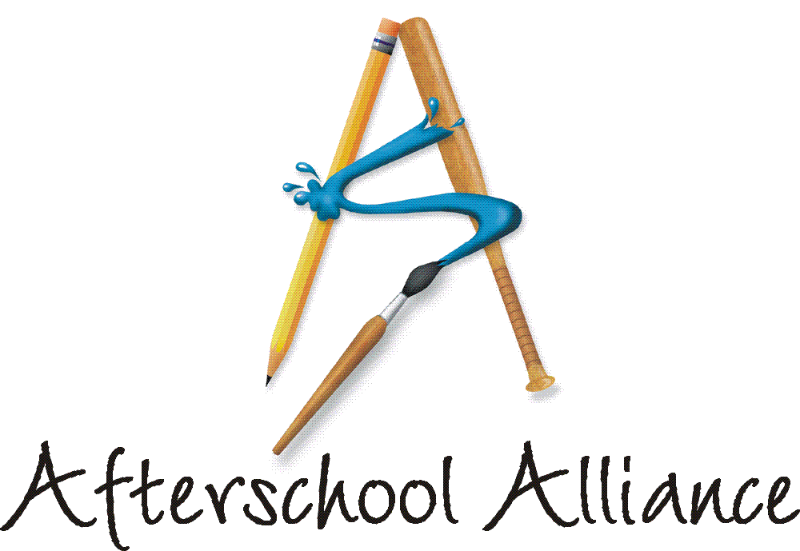
NEWS RELEASE CONTACT: Gretchen Wright
August 27, 2003 202/371-1999

Afterschool Program Directors, Parents, Kids Across the Nation
Gear Up for Largest-Ever Rally for Afterschool

October 9 is Lights On Afterschool! 2003

WASHINGTON, DC – “Afterschool is key to kids’ success,” will be the rallying cry at thousands of events across the country in support of afterschool programs on October 9. The fourth annual Lights On Afterschool!, sponsored by the Afterschool Alliance and the JCPenney Afterschool Fund, will bring together community leaders, policy makers, parents, neighbors and kids for the nation’s largest annual rally for afterschool programs. The event will call attention to afterschool programs and the resources required to keep the lights on and the doors open.
“This year has brought challenges, as afterschool programs and advocates have had to fight funding cuts and work hard to keep the doors open at programs across the country,” said Afterschool Alliance Executive Director Judy Y. Samelson. “More Americans than ever are speaking out for the afterschool programs that keep kids safe, help working families and improve academic achievement. We expect Lights On Afterschool! 2003 will be our most successful event ever.”

Lights On Afterschool! was launched in October 2000. That year more than 1,200 events were held across the country. By last year, more than half a million people rallied in more than 5,600 communities to show their support for keeping the lights on afterschool, and 25 governors proclaimed Lights On Afterschool! Day. Organizers expect this year’s event to be even larger. Actor and children’s activist Arnold Schwarzenegger is the National Chair of Lights On Afterschool! again this year.

To date, more than 70 organizations have joined Lights On Afterschool! 2003 as national partners. Among them are the National Governors Assocation, U.S. Conference of Mayors, Association of Maternal and Child Health Programs, Reading is Fundamental and United National Indian Tribal Youth.

The Afterschool Alliance is a nonprofit public awareness and advocacy organization supported by a group of public, private, and nonprofit entities dedicated to ensuring that all children and youth have access to afterschool programs by 2010. Arnold Schwarzenegger is Honorary Chair of the Afterschool Alliance. Information is available at www.afterschoolalliance.org.

The JCPenney Afterschool Fund is a nonprofit, 501(c)(3) organization contributing financial support to five of America’s leading after school advocates – the YMCA of the USA, Boys & Girls Clubs of America, 4-H, Junior Achievement and the Afterschool Alliance. Support from the JCPenney Afterschool Fund helps provide safe, fun and educational after school programs and raise awareness of the need for more such programs across the country.

# # # #

