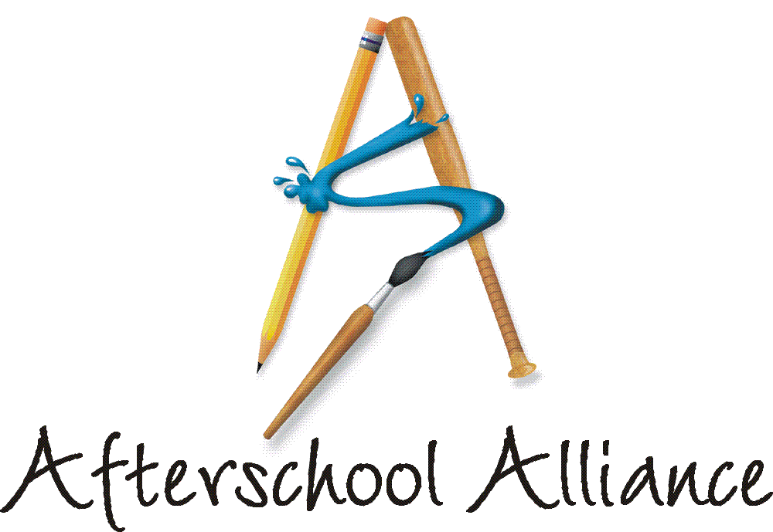
NEWS RELEASE CONTACT: Gretchen Wright
September 4, 2003 202/371-1999

Afterschool Programs Plan Unique, Diverse Events
for Lights On Afterschool! on October 9

Across the country, in large cities and small towns, plans are underway for the largest ever nationwide rally for afterschool. Lights On Afterschool! 2003 will kick off with a rally at the Texas Capitol on Saturday, October 4. Then on Thursday, October 9, parents, children, community leaders and policy makers will come together at more than 5,000 sites across the country to show their support for afterschool programs.

Now in its fourth year, Lights On Afterschool! will feature thousands of unique, community-oriented events, including: a relay race at a State Capitol; an open house at an afterschool program on a military base; the unveiling of special Lights On Afterschool! light fixtures; and a diversity celebration featuring Mexican dance. Lights On Afterschool! is organized by the Afterschool Alliance. The JCPenney Afterschool Fund is National Presenting Sponsor.

Lights On Afterschool! will kick-off in Austin, Texas on October 4, when hundreds will gather at the State Capitol to watch children from local afterschool programs complete the final mile of a torch race to raise awareness that thousands of children in the Greater Austin area do not have access to quality, affordable afterschool care. At the conclusion of the race, the children will hand their torches to local and state policy makers and ask them to bring quality, affordable afterschool care to every school-age child in Travis County. University of Texas Baseball Coach Augie Garrido is honorary chair of the event and several University of Texas star athletes are scheduled to attend. The Travis County Afterschool Network is organizing the race and rally. For information, contact Anna Land at 512/502-0681.
On October 9, School Age and Youth Services in Fort Stewart, Georgia will host an open house for returning military personnel at its afterschool program. Parents returning from overseas will have the opportunity to see the fun, educational and exciting activities that engage their children. The Lights On Afterschool! event will include face painting, food and student performances. It will be open to the entire community. “The military service personnel are grateful for all of the help and support we provide, especially during their deployment overseas,” said Brenda Morgan, lead program technician at School Age and Youth Services. “Not only do we provide the children with an enriching afterschool program, but we provide them with the reassurance and love they need while their parents are away.” For information, contact Brenda Morgan at 912/767-5662.

– more –
Add One

Students in the 4 Counties for Kids afterschool program in Jacksonville, Illinois are working with community partners and local businesses to create light fixtures (including table lamps, floor lamps and wall sconces) to prepare for their Lights On Afterschool! event. On October 9, local dignitaries will unveil the new light fixtures at open houses at 21 sites and “turn the lights on afterschool.” Later this fall, the light fixtures will be auctioned off to corporate sponsors and community members to raise money for the afterschool programs. Each open house will also feature student performances and opportunities for guests to participate in afterschool activities. For information, contact Keri Tate at 217/245-6858.
The 21st Century Community Learning Centers program in Logan, Utah will host two events during the week of Lights On Afterschool! At a diversity celebration on October 7, dancers from Mexico will perform traditional dances to welcome English-as-a-Second-Language students and their parents to Mount Logan Middle School. Following the performance, the dancers will visit several afterschool sites to teach students in the programs a Mexican dance. On October 9, each afterschool site will host a Lights On Afterschool! celebration at which students will perform the dances they learned. The events will be open to the entire community and will also feature displays of students’ artwork, crafts and technology projects, as well food, games and other fun activities. For information, contact Dan Johnson at 435/755-2370.

In California, the Modesto City Schools 21st Century Afterschool Learning Programs, the Stanislaus Office of Education and the Haven’s Women Center will co-host a two-day, nine-city Lights On Afterschool! celebration. On October 9, John’s Incredible Pizza Amusement Park will open its doors to students, parents, program providers and community leaders. The day will be filled with student performances, testimonials about the benefits of afterschool, speeches from local dignitaries, and games, food and other entertainment. The following day, there will be a street fair in downtown Modesto highlighting children’s safety and the need for more afterschool programs, and featuring information booths, safety presentations and entertainment. Other participating organizations include the Modesto Bee; Adult Education Technologies, Inc.; Stanislaus County Police Activities League; and City of Modesto Parks Recreation and Neighborhoods Department. For information, contact John Ervin at 209/569-2800.

Actor and children’s advocate Arnold Schwarzenegger is the National Chair of Lights On Afterschool! again this year. A complete list of Lights On Afterschool! events across the country is available on the Afterschool Alliance web site at www.afterschoolalliance.org.

The Afterschool Alliance is a nonprofit public awareness and advocacy organization supported by a group of public, private, and nonprofit entities dedicated to ensuring that all children and youth have access to afterschool programs by 2010.

The JCPenney Afterschool Fund is a nonprofit, 501(c)(3) organization contributing financial support to five of America’s leading after school advocates – the YMCA of the USA, Boys & Girls Clubs of America, 4-H, Junior Achievement and the Afterschool Alliance. Support from the JCPenney Afterschool Fund helps provide safe, fun and educational after school programs and raise awareness of the need for more such programs across the country.

# # # #

