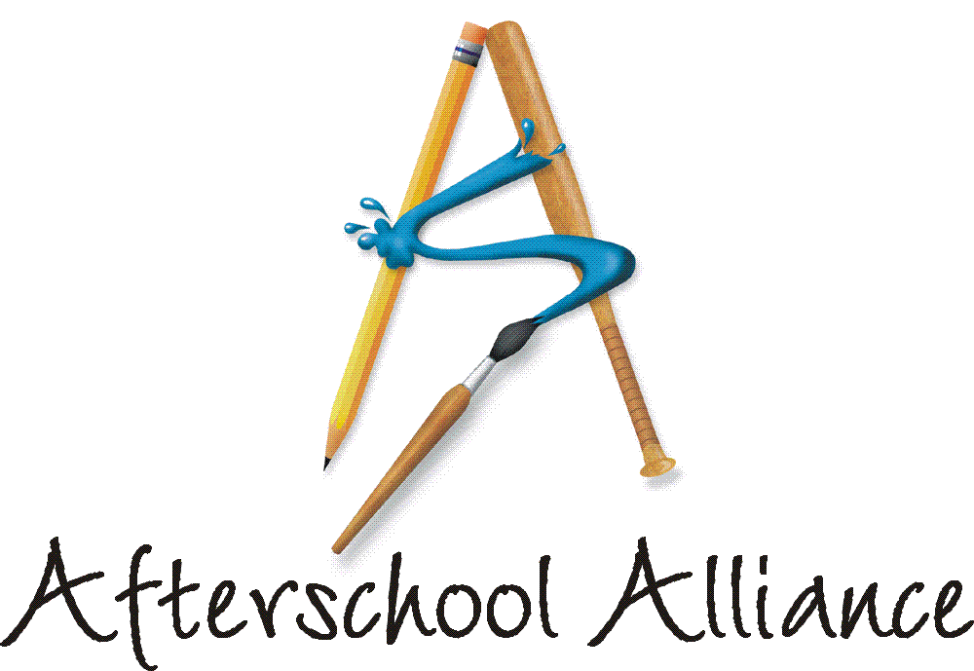
NEWS RELEASE CONTACT: Gretchen Wright
September 16, 2003 202/371-1999

Have You Seen This Poster?

Brilliant and colorful light bulbs decorated by students in afterschool programs are the centerpiece of a poster that educators across the country are using to announce their 2003 Lights On Afterschool! events. The light bulbs were decorated at previous years’ Lights On Afterschool! events by children of all ages. Forty thousand light bulbs made of construction paper and bearing children’s designs and messages about the importance of afterschool programs were delivered to Congress and displayed on Capitol Hill earlier this year. Most of the light bulbs urge lawmakers to “keep the lights on after school.” Lights On Afterschool! is organized by the Afterschool Alliance. The JCPenney Afterschool Fund is National Presenting Sponsor.

This year, Lights On Afterschool! events will take place in every corner of the country. They run the gamut from open houses featuring performances by afterschool students to outdoor community fairs to block parties featuring helicopter demonstrations by National Guard units. Local event organizers are hanging the posters in schools, supermarkets, community centers, afterschool programs and other venues to invite communities to participate in the 2003 rallies. Again this year, more than 5,000 sites are expected to hold Lights On Afterschool! events.

Actor and children’s advocate Arnold Schwarzenegger is National Chair of Lights On Afterschool! for the third consecutive year. A complete list of Lights On Afterschool! events around the country is available at www.afterschoolalliance.org.

The Afterschool Alliance is a nonprofit public awareness and advocacy organization supported by a group of public, private, and nonprofit entities dedicated to ensuring that all children and youth have access to afterschool programs by 2010.

The JCPenney Afterschool Fund is a nonprofit, 501(c)(3) organization contributing financial support to five of America’s leading after school advocates – the YMCA of the USA, Boys & Girls Clubs of America, 4-H, Junior Achievement and the Afterschool Alliance. Support from the JCPenney Afterschool Fund helps provide safe, fun and educational after school programs and raise awareness of the need for more such programs across the country.
# # # #

NOTE: Click here for new Lights On Afterschool! poster.

