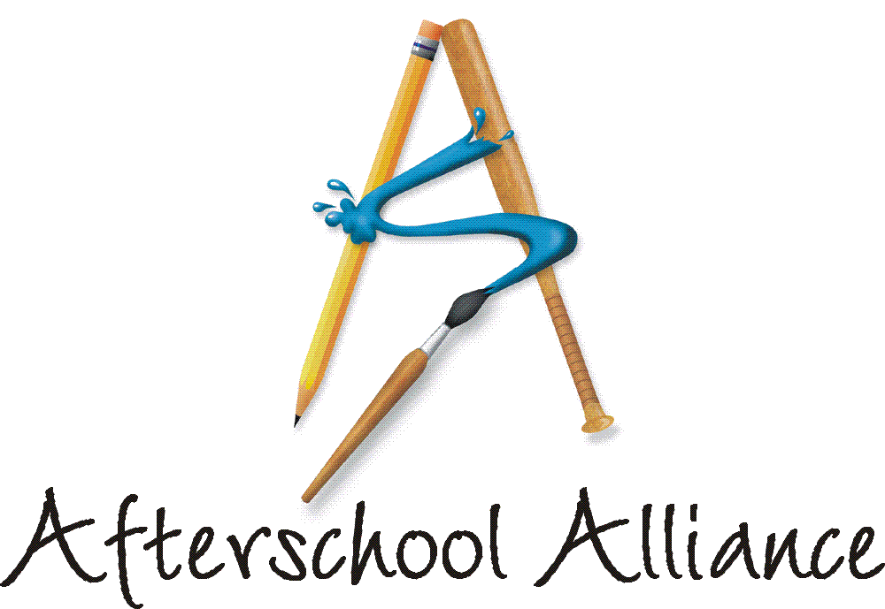
NEWS RELEASE CONTACT: Gretchen Wright
September 30, 2003 202/371-1999

Helicopter Demonstration, Pajama/Reading Night,
Mile of Nickels, ‘Storytime with the Mayor’ to be
Among Diverse, Educational Lights On Afterschool! Events This Year

October 9 will mark the fourth annual Lights On Afterschool!, a nationwide series of rallies at which hundreds of thousands of Americans will demonstrate their support for afterschool programs. The more than 5,000 events around the country this year will be as diverse as the nation’s afterschool programs and the children and families they serve. Lights On Afterschool! is organized by the Afterschool Alliance. The JCPenney Afterschool Fund is National Presenting Sponsor.

“From Fort Bragg to Fairbanks and everywhere in between, students, parents, community members and educators will join with local and state leaders to send the message that afterschool is key to kids’ success,” said Afterschool Alliance Executive Director Judy Y. Samelson. “This year’s Lights On Afterschool! will be the most exciting and diverse nationwide rally for afterschool ever held.”

“Lights On Afterschool! is a celebration of afterschool and a reminder about how much afterschool programs matter to families and communities,” said Ed Solczak, Vice President of the JCPenney Afterschool Fund. “Afterschool programs help children flourish while keeping them safe after the school day ends. JCPenney and the JCPenney Afterschool Fund are deeply committed to afterschool programs.” Hundreds of JCPenney store managers are expected to participate in Lights On Afterschool! events in their communities on October 9.

A list of Lights On Afterschool! events around the country is available at http://www.afterschoolalliance.org/loa_2003/find.cfm. Among the events this year:

ARKANSAS: The Arkansas National Guard will figure prominently in Lights On Afterschool! in Eureka Springs where the focus will be on the need for afterschool programs. At a block party on October 9, the National Guard’s Drug Reduction Team will conduct a helicopter demonstration and a presentation about why children should stay drug-free and attend afterschool programs. Students at the Eureka Kids afterschool program will demonstrate their afterschool activities and decorate paper light bulbs with messages about the importance of afterschool. For more information, contact Barbara Deschner at 479/253-8006.

more
Add One

NORTH DAKOTA: At the Grand Forks Airforce Base, Lights On Afterschool! comes during Fire Safety Week. The Youth Center/Boys and Girls Club of the Grand Forks Airforce Base will hold a Community Safety/Pajama and Reading Night. The local fire deparment will conduct a safety program that includes a model house for children and parents to practice fire safety. Lights On Afterschool! guests will have the chance to join in storytelling, reading and games. Local partners include the fire department, Women Infants and Children Program, Boy Scouts, Girl Scouts, Family Advocacy Office, and local law enforcement and other agencies. For more information, contact Dawn Thompson at 701/747-3151.

SOUTH CAROLINA: In Charleston, the largest Latino afterschool program in the state, The Good News Afterschool Enrichment, will hold a “A Mile of Nickels” fundraiser for Lights On Afterschool! to pay for building repairs. The program has distributed yards of ribbon to local stores, so customers can donate nickels. There will be 1,765 feet of ribbon at the event, and children will lay the nickels down on it. Guests will be able to participate in carnival games to win prizes and enjoy hot dogs, hamburgers and drinks donated by local merchants. For more information, contact Rezinda White at 843/552-5484.

WASHINGTON: Literacy will be the focus of Lights On Afterschool! at TCSC-Cascade View Elementary School in Seattle. Guests will tour the program and visit rooms where they can join numerous activities, including storytime with the mayor, puppet shows, Spanish/English stories, computers set up with reading programs, and make-your-own-story books. In addition to Mayor Greg Nickels, invited guests include the Seattle school superintendent and several police officers and fire fighters who will bring their firetruck. For more information, contact Lori Hopper at 206/901-7719.

Actor and children’s advocate Arnold Schwarzenegger is National Chair of Lights On Afterschool! More information is available at www.afterschoolalliance.org.

The Afterschool Alliance is a nonprofit public awareness and advocacy organization supported by a group of public, private, and nonprofit entities dedicated to ensuring that all children and youth have access to afterschool programs by 2010.

The JCPenney Afterschool Fund is a nonprofit, 501(c)(3) organization contributing financial support to five of America’s leading after school advocates – the YMCA of the USA, Boys & Girls Clubs of America, 4-H, Junior Achievement and the Afterschool Alliance. Support from the JCPenney Afterschool Fund helps provide safe, fun and educational after school programs and raise awareness of the need for more such programs across the country.

# # # #

