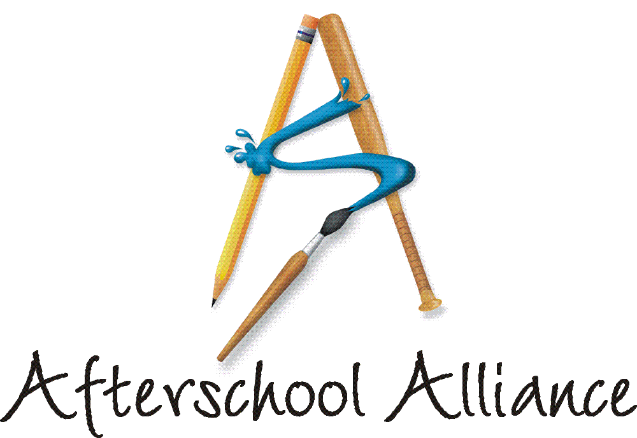
NEWS RELEASE CONTACT: Gretchen Wright
October 5, 2003 202/371-1999

California and Texas Kick Off Lights On Afterschool! 2003

Weekend Events in Los Angeles and Austin Launch Nationwide Rally for Afterschool; Events Feature Afterschool Champion Arnold Schwarzenegger,
Members of Congress, Sheriffs, Judges, Business Leaders

LOS ANGELES, CA – Actor and children’s activist Arnold Schwarzenegger helped more than 4,000 Los Angeles children send the message that afterschool is key to kids’ success at Birmingham High School here today, as Lights On Afterschool! kicked off for 2003. Organized by the Los Angeles Unified School District’s (LAUSD) Beyond the Bell, with LA’s BEST and 20 other afterschool agencies, the event featured student performances and remarks by LAUSD Associate Superintendent John Liechty, Afterschool Alliance Executive Director Judy Y. Samelson and JCPenney Afterschool Fund Vice President Ed Solczak.

Organized by the Afterschool Alliance, Lights On Afterschool! is the nation’s largest rally for afterschool programs. More than 5,000 events will take place this week in every corner of the country, with most set for Thursday, October 9. Arnold Schwarzenegger is National Chair of Lights On Afterschool! for the third consecutive year. The JCPenney Afterschool Fund is National Presenting Sponsor.

At another Lights On Afterschool! kick-off rally yesterday, hundreds of children in Austin, Texas carried the message that America needs more afterschool programs to their State Capital. The children from local afterschool programs completed the final mile of a torch race to raise awareness that thousands of children in the Greater Austin area do not have access to quality, affordable afterschool programs. At the conclusion of the race, the children handed their torches to local and state policy makers and asked them to make afterschool programs available to every school-age child in Travis County. The event featured Congressman Lloyd Doggett and sheriffs, district attorneys, business leaders and others.

more
Add One

“In communities from California to Texas to Maine this week, students, parents, community members, educators, religious and business leaders will join athletes, actors, policy makers, and state and local leaders to send the message that we need more afterschool programs in this country,” Samelson said. “This week, more Americans than ever will rally in support of the afterschool programs that keep kids safe, help working families and improve academic achievement. We expect this year’s Lights On Afterschool! to be the most exciting and diverse nationwide rally for afterschool ever held.”

“Lights On Afterschool! is a celebration of afterschool and a reminder about how much afterschool programs matter to families and communities,” said Ed Solczak, Vice President of the JCPenney Afterschool Fund. “Afterschool programs help children flourish while keeping them safe after the school day ends. JCPenney and the JCPenney Afterschool Fund are deeply committed to afterschool programs.” Hundreds of JCPenney store managers are expected to participate in Lights On Afterschool! events in their communities on October 9.

Nationwide, as many as 15 million latchkey children have no adult supervision during non-school hours. These youth are more likely to become involved in risky behavior, and are missing important opportunities to learn and grow. Afterschool programs offer young people safe, enriching, fun and engaging places to go once the school day is over. Research shows that afterschool programs are a good investment. They improve academic achievement, keep kids safe, help working families, and teach children social skills and conflict resolution. Afterschool programs also lead to increased school attendance and lower dropout rates.

Lights On Afterschool! was launched in October 2000. More than half a million people are expected to participate this year. The more than 120 organizations that are supporting Lights On Afterschool! this year include: American Association of Museums; Boys & Girls Clubs of America; Charles Stewart Mott Foundation; 4-H Afterschool; Girl Scouts of the USA; Inner-City Games Foundation; Junior Achievement Inc.; National Association for Bilingual Education; National Governors Association; National Indian Education Association; National Parent Teacher Association; Open Society Institute; United Way of America; and YMCA of the USA.

The Afterschool Alliance is a nonprofit public awareness and advocacy organization supported by a group of public, private, and nonprofit entities dedicated to ensuring that all children and youth have access to afterschool programs by 2010. Arnold Schwarzenegger is Honorary Chair of the Afterschool Alliance. Information is available at www.afterschoolalliance.org.

The JCPenney Afterschool Fund is a nonprofit, 501(c)(3) organization contributing financial support to five of America’s leading after school advocates – the YMCA of the USA, Boys & Girls Clubs of America, 4-H, Junior Achievement and the Afterschool Alliance. Support from the JCPenney Afterschool Fund helps provide safe, fun and educational after school programs and raise awareness of the need for more such programs across the country.

# # # #

